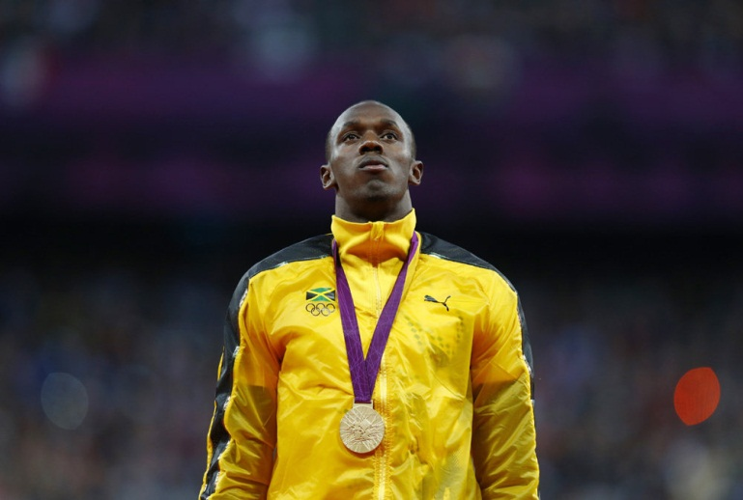

Usain Bolt
Sport: Running
Born: 21 August 1986
Country: Jamaica
Height: 195cm
Weight: 86kg
Nickname: ‘Lightning’ Bolt
Gold medals in London Olympics: 100m, 200m, 4x100m relay
Best time/ World record: 100m in 9.58 seconds; 200m in 19.19seconds

M.J. Hello, I am Marcin Jachym from the Sport’s Editors Polish Television. I have some questions for you.
U.B . Hallo Marcin, I am ready, I know Polish people, you are very good athletic fans. You have got very good athletes, for example Tomasz Majewski, he is the strongest man in the shot put.
M.J. Thank you, Usain. I know, you have a Nickname. What is this?
U. B. I am ‘Lightning’ Bolt.
M.J. It is the adequate Nickname; you are the fastest man in the world. How do you feel as the record breaker?
U.B. I’m very happy. It always was my dream.
M.J. Were you interested in running, when you were young?
U.B. No, in no case. My favourite sport was football and cricket.
M.J. Why don’t you train this sport disciplines?
U. B. Then my cricket coach noticed I run fast. He told me to try track events.
M.J. And it was very good decision, wasn’t it ?
U.B. I began to run and I run fast. I also ate fast food, played basketball and partied a lot. I didn’t train very hard and my coaches weren’t too pleased. I also liked to play jokes. One day I didn’t want to run so I hid. The police looked for me and they found me in the back of a van. They weren’t very pleased, either!
M. J. And what was next?
U.B. I run faster and faster. I had a lot of injuries and two car’s crashes, but I got better and I run again. Then in 2005 I got a new coach. This coach wanted me to be more serious and to train harder. It worked! I became a superstar.
M.J. You are the only man to hold the 100m and 200m World and Olympic titles at the same time. Will you break those records during the next Olympics?
U. B. Yes, I think so. I plan to stop joking and to be more serious. I won’t be playing around because I want to break those records.
M.J. Thank you very much for your openness.
U. B. It was my pleasure. Bye Marcin
