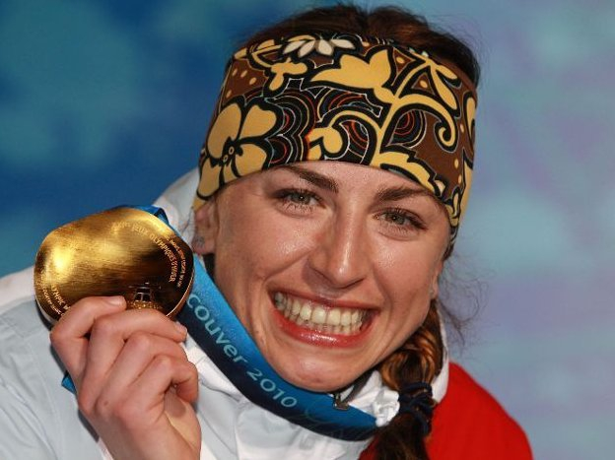
Justyna
Kowalczyk
My favourite sport star is Justyna K.owalczyk. Justyna Kowalczyk was born on 19 Jan. 1983.
Her favorite sport is cross-country skiing.
-hallo Justyna
-HEllo.
-I ask you two questions
-Ok
-how many gold medals did you get?
-I gained 9 gold medals.
-Do you have any siblings?
-I have older siblings Wioletta , Ilona and Tomasz.
-Thank you for your reply to my questions.
-goodbye.
-Goodbye.

Ewelina Górka

