I invite you to an interview with the Polish player Robert Lewandowski. 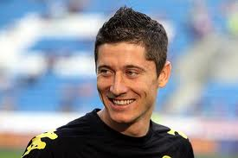 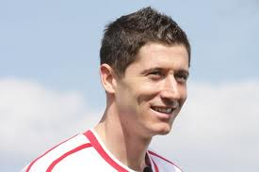

Reporter - Robert, where did you start your career?
Robert – I started my career at the club Partisan Leszno. In 2008, I started to play for Lech Poznan
Reporter – Have you ever played representative matches?
Robert - Yes I did. In 2008, I played three friendly matches against England, Belarus and Finland
Reporter - And how it went?
Robert - Unfortunately, not a single goal was scored
Reporter - Are you satisfied with your career?
Robert - Yes, I am
Reporter - Thank you for this interesting interview. Good luck in the future career. Goodbye.
Robert – Thanks!

